

Corporate Plan

2025-26

Corporate Plan 2025–26 **I**

##### Publication information

**Acknowledgement of Country**

The Office of the Inspector-General of Aged Care acknowledges the traditional owners of country throughout Australia, and their continuing connection to land, water and community. We pay our respects to them and their cultures and to elders both past and present.

**Publication details**

© Commonwealth of Australia 2025

This work is copyright. Apart from any use as permitted under the Copyright Act 1968, no part may be reproduced by any process without prior written permission from the Office of the Inspector- General of Aged Care.

Produced by the Office of the Inspector-General of Aged Care, Barton, Canberra, ACT.

Requests and enquiries concerning the contents of the report should be addressed to:

Office of the Inspector-General of Aged Care PO Box 350

Woden ACT 2606, Australia Email: [contact@igac.gov.au](mailto:contact@igac.gov.au)

This report is also available from our website: [www.igac.gov.au](http://www.igac.gov.au/).

Contents

Introduction 2

Inspector-General’s Foreword 2

Purpose 4

Vision 4

Who we are 4

Why we were established 4

Our strategic framework 5

Sharing what we learn 7

Our commitment to engagement 8

Partnering with Aboriginal and Torres Strait Islander peoples 9

Key activities 10

How we deliver on our purpose 10

Operating context 11

Environment 11

Capability 11

Organisational structure 13

Technology 13

Our principles 14

Risk oversight 15

Cooperation 15

Performance 16

Our outcome objective 16

# Introduction

## Inspector-General’s Foreword



##### As the Accountable Authority, I am pleased to present the Office of the Inspector-General of Aged Care

Corporate Plan 2025–26, which covers the reporting period 2025–26 to 2028– 29, as required under section 35(1)(b) of the *Public Governance, Performance and Accountability Act 2013* and in accordance with section 16E of the Public Governance, Performance and Accountability Rule 2014.

As Inspector-General of Aged Care, I am proud to present you with the strategic direction and priorities of my Office as we consolidate our mission to oversee and improve the Australian Government’s administration of the aged care system.

Our role is clear: to scrutinise, assess and call out where the system is falling short, while also highlighting opportunities for positive change.

We do not investigate individual complaints or providers; instead, we focus on the broader picture – on system-level reform that centres human rights, dignity and compassion. Our independence allows us to speak openly and

without bias, and our work is grounded in data, evidence and the lived experiences of older people.

We are not quite two years old as an Office but our approach to delivering our mission is clear: we need to ensure the government can and does deliver the noble vision of aged care articulated by the new *Aged Care Act 2024*. That is, care that embodies

kindness, compassion and respect for the life experiences, self-determination, dignity, quality of life, mental health and wellbeing of the older person.

In holding the government to account for barriers or gaps in administering and regulating the aged care system, we are not looking

to find fault for fault’s sake. All of our work asks: Have the government’s reforms had the impact we should expect by now? Are we on track to deliver the transformation the Royal Commission called for and the new Act promises?

Our corporate approach has therefore been built to facilitate a workplace, workplan and a staff culture that individually and collectively

answers these questions. In doing so, we also recognise the backdrop of challenges faced by government: an ageing population, constrained resources and increasing demand. We also know that failing to get this right could cost more – not just financially but, importantly, for human dignity and wellbeing.

In the last 6 months we have firmly set the strategic direction of the agency, publicly committing to the way in which we will deliver our legislative remit. We have also publicly committed to some key approaches to which we want to be held openly accountable by the people of Australia. These are:

1. **A Strategic Framework** which informs the public of the issues we will prioritise in our work, why, how we will deliver these and what impact we are trying to achieve.
2. Our dedication to specific **principles of engagement**, that focus on **inclusive,**

**respectful, and equity-driven practices**. They emphasise listening deeply to lived experiences – especially those of older people, carers

and diverse communities – and ensuring that engagement is trauma-informed, culturally appropriate and transparent. The approach also includes meaningful collaboration with First Nations peoples, guided by the concept of dadirri, which means deep, respectful listening.

1. **Our Statement of Commitment to the National Agreement on Closing the Gap**, which is a strong, actionable pledge to embed Aboriginal and Torres Strait Islander leadership, knowledge and cultural practices into aged care oversight. It prioritises genuine engagement, shared decision making and cultural safety, aligning with the four Priority Reforms of

the National Agreement. The commitment is grounded in accountability, transparency and

reciprocity, aiming to transform aged care outcomes through reciprocity, community-led approaches and Indigenous data sovereignty.

A seminal undertaking for us in early 2025 was our report into the government’s implementation of the recommendations of Royal Commission into Aged Care Quality and

Safety. In that report we ask a critical question: what actions would be most transformative

in moving us from where we are today to that very system that centres rights and embodies just the kindness, compassion, quality of life and dignity I described earlier?

What we heard from people, providers, loved ones, the government and those who have lived and living experience has informed the key focus areas of our next 12 months of work.

Our Corporate Plan will underpin the delivery of these focus areas.

In addition, we intend in the next 12 months to bring to life our role in systemic oversight of the aged care complaints process. The next

Corporate Plan should see this as an embedded function of our agency.

As you read this plan, I invite you to reflect on the kind of aged care system you would want to grow old in. Our Office will continue to work towards a future where every older person in

Australia is not merely cared for but truly lives – being connected, valued and supported.

###### Natalie Siegel-Brown

Inspector-General of Aged Care 4 August 2025



# Purpose

##### Our purpose is to ensure integrity and accountability of the aged care system through independent, informed oversight. We drive meaningful change by calling out serious barriers and holding up to the light models that would create the meaningful improvement needed to achieve this vision.

## Vision

Our vision is an aged care system where every person receives kind, compassionate, high- quality care that promotes their rights, identity and independence.

## Who we are

The Inspector-General of Aged Care is an independent statutory office holder, supported by the Office of the Inspector-General of

Aged Care. Established under the *Inspector- General of Aged Care Act 2023* (the IGAC Act), our Office provides informed, system-wide oversight of how aged care is delivered and administered by the Australian Government.

We identify where the system is working well, highlight serious issues and make

recommendations that promote dignity, human rights and high-quality care for older people across Australia.

## Why we were established

The Royal Commission into Aged Care Quality and Safety (Royal Commission) recommended that the Australian Government create

an independent Inspector-General and a supporting office. This was to ensure the aged care system is subject to ongoing, impartial oversight and that government agencies are held accountable for their decisions, processes and performance.

To turn our purpose into clear priorities and action, we use a Strategic Framework that guides how we deliver independent, evidence-based oversight of the system.

## Our strategic framework

Our Strategic Framework outlines how we deliver our legislative remit to monitor, investigate and report on the Australian Government’s administration and regulation of the aged care system.

It helps us take a consistent and transparent approach to everything we do. This includes how we set priorities through our Annual Work Plan and where we focus our attention.

The framework informs our decision making by helping us identify risks and barriers in aged care. It directs our efforts towards areas where improved care models can be developed and meaningful outcomes achieved.

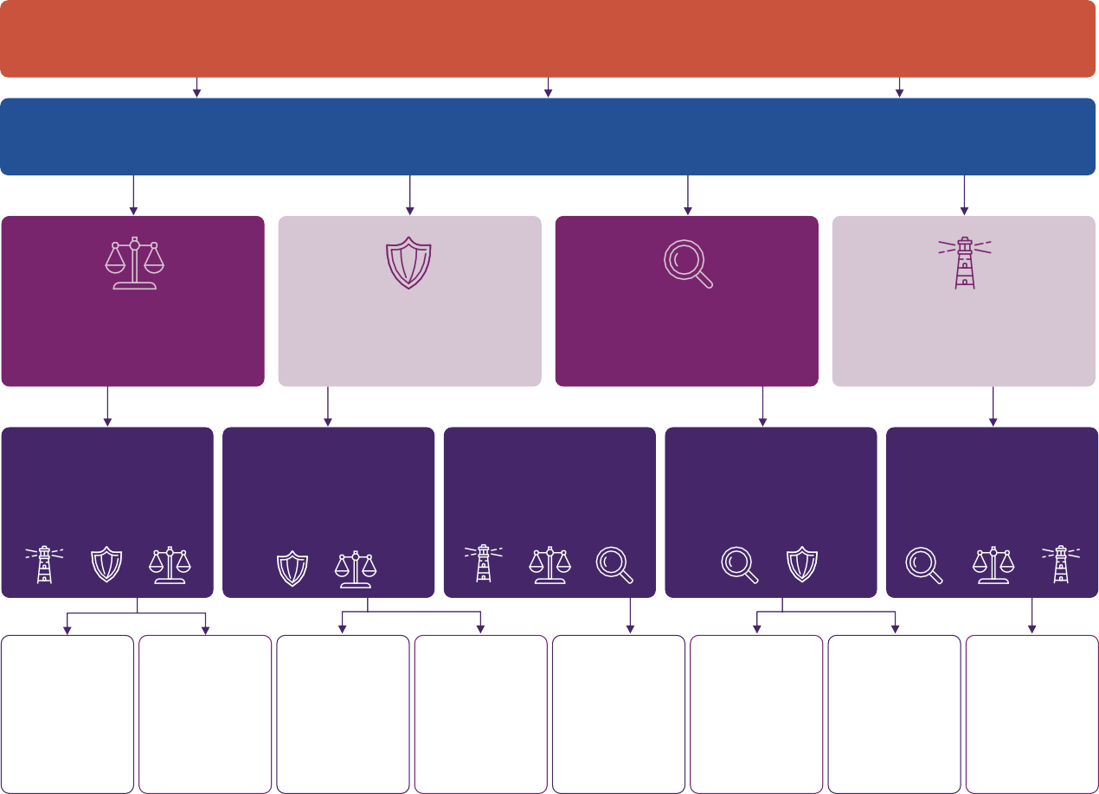

**VISION:** an aged care system where every person receives kind, compassionate, high-quality care that promotes their rights, identity and

independence

**PURPOSE:** To ensure integrity and accountability of the aged care system through independent, informed oversight. We drive meaningful change by calling out serious barriers and holding up to the light models that would create the meaningful improvement needed to achieve this vision

**Outcomes**

Drive meaningful change to

achieve rights-based, high-quality care

Build trust and conﬁdence

in the aged care system

Promote system-wide

transparency

Illustrate how government

can achieve equitable, person-centred aged care

**Objectives**

Our work calls out the

systemic problems and opportunities that lead to the greatest change in aged care

We maximise the inﬂuence of our

work. We build and cement a strong, trusted proﬁle in both the aged care sector and the public landscape as an oversight body and agent for positive change.

Our work highlights

experiences of those most vulnerable, and who face the greatest barriers to equity in the upholding of their rights.

Our way of working and

our aims are well known.

We are a safe, welcoming,

capable organisation of deep integrity, that people love to work for.

**Activities**

|  |  |  |  |  |  |  |  |
| --- | --- | --- | --- | --- | --- | --- | --- |
| Review the issues of | Develop, maintain | Develop and deliver | Proactively pursue | Establish ongoing | Publish our | Publish | Establish and |
| greatest weight in | and enhance robust | impactful | media and | advisory mechanisms | approach to work | commitments to | maintain a safe, |
| transforming the | intelligence and | information, | events/opportunities | with diverse |  | implement National | happy culture in the |
| Aged Care system to | monitoring systems | education and | to inﬂuence the | stakeholders, |  | Agt Closing the Gap | agency and strong |
| achieve the objectives  set out in the *Aged Care Act 2024* |  | awareness of our  ﬁndings and recommendations | agenda | especially those with  lived experience |  |  | corporate  infrastructure |

*Figure 1: Office of the Inspector-General of Aged Care Strategic Framework*

Outcomes

Our Strategic Framework identifies four outcomes that support our purpose. These outcomes describe the broader impacts we aim to achieve through our oversight and engagement activities:

1. Drive meaningful change to achieve rights- based, high-quality care.
2. Build trust and confidence in the aged care system.
3. Promote system-wide transparency.
4. Illustrate how government can achieve equitable, person-centred aged care.

Objectives

Our objectives explain how we will achieve these outcomes and where we will focus our resources and efforts in the coming years.

1. Our work calls out the systemic problems and opportunities that lead to the greatest change in aged care.
2. We maximise the influence of our work. We build and cement a strong, trusted profile in both the aged care sector and the public landscape as an oversight body and agent for positive change.
3. Our work highlights experiences of those most vulnerable and who face the greatest barriers to equity in the upholding of their rights.
4. Our way of working and our aims are well known.
5. We are a safe, welcoming, capable organisation of deep integrity, that people love to work for.

Together, the objectives and activities in our Strategic Framework shape the priorities in our Annual Work Plan. They guide how we allocate resources and focus our efforts to deliver meaningful, lasting change across the aged care system.

Annual Work Plan

Each year the Inspector-General develops and publishes an Annual Work Plan, as required under our legislation. While publishing the Annual Work Plan fulfills a legislated obligation, we also view it as a vital demonstration to

the community that we have listened to their priorities in overseeing the aged care system – and that we are committed to acting on them. The plan sets out the specific activities,

projects and priorities we will focus on over the coming year. It translates the long-term goals of our Strategic Framework into clear, practical actions.

In 2025–26 our Annual Work Plan activities have been determined based on the community’s response to the critical question: what actions would be most transformative in moving us from where we are today, to an aged care system that centres rights and embodies the kindness, compassion, quality of life and dignity promised by the new Aged Care Act 2024? This is the rationale behind the plan’s theme: From Aspiration to Action: Realising Human Rights and Person-Centred Care in Aged Care.

This question was the centrepiece of the comprehensive consultations we conducted (and submissions received) for our report into the government’s implementation of the recommendations of Royal Commission into

Aged Care Quality and Safety. In that report we heard from people who have lived and living experience, from providers, loved ones and the government.

The Annual Work Plan reflects our commitment

to improving the aged care system by supporting high-quality, rights-based care, strengthening public trust and promoting transparency.

By aligning our work with the outcomes in our Strategic Framework, we can respond to changes in the aged care environment and ensure our efforts are targeted for maximum impact.

This Corporate Plan will underpin the delivery of these focus activities.

## Sharing what we learn

Our Annual Work Plan guides our priorities and shapes the insights we share from our work. These insights are shared through clear and accessible information that helps

people understand how the aged care system is performing and where improvements are needed. By identifying serious barriers and showing how the government’s ambitions for aged care might be achieved, we contribute to informed public discussion and help improve outcomes for everyone who relies on or works in the aged care system.

We aim to empower people by sharing insights that build awareness of what quality, compassionate and rights-based aged care looks like in practice.

We are committed to sharing our work in ways that are practical, meaningful and easy to access. We do this through reports, fact sheets, webinars and other resources that support the sector and the entire community to understand the importance of our findings – and what they mean the government may need to change.

## Our commitment to engagement

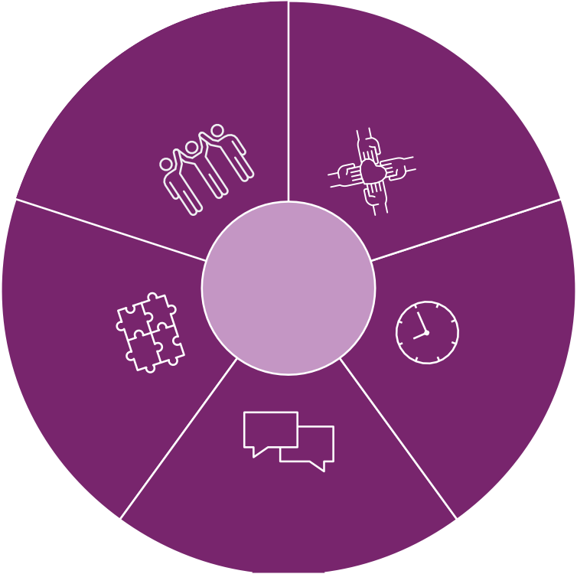

**Engagement principles**

e

e

m

f

o

d

A

c

n

c

c

a

e

n

s

p

e

s

i

a

p

b

r

l

O

e

ti

c

a

i

n

p

d

a

r

e

ti

n

s

o

o

p

n

ti

e

c

a

tf

r

g

u

o

n

l

i

b

n

a

r

a

l

l

e

o

l

c

d

n

g

a

n

i

o

g

n

O

t

n

e

m

e

d

g

n

a

a

g

n

y

e

l

e

l

u

m

f

e

i

s

T

o

I

p

n

e

r

c

u

l

n

u

p

g

s

i

a

v

g

e

e

a

n

m

n

d

e

o

f

n

a

ti

i

t

a

r

c

k

i

c

n

a

u

b

d

m

Building on our commitment to transparency, we actively engage with the people and organisations involved in our work to inform and improve what we do. We listen to and learn from older people, their families, carers, aged care workers, providers and community representatives.

We value the voices of people from all backgrounds, abilities, genders and sexual orientations, and are committed to making sure our work reflects and responds to the diversity of Australia’s population. This includes how we engage, communicate, design programs and share information.

We are working to improve the accessibility of our materials by using plain language and

offering information in a range of formats, such as Easy Read and translations, so that more people can participate in and benefit from our work.

Our engagement is guided by clear principles that support respectful, inclusive and meaningful participation.

These Engagement Principles help ensure everyone feels heard and valued:

1. **Inclusive and fair engagement:** we listen to all voices, with a focus on older people and those who face barriers to participation.
2. **Accessible and respectful participation:** we use plain language, offer information in different formats and adapt our approach to meet individual and cultural needs – in ways that are safe, inclusive and trauma informed.
3. **Timely and purposeful engagement:** we engage early, give people time to prepare and clearly explain the purpose of each activity.
4. **Open communication and feedback:** we are open and transparent about how input will be used and share updates on decisions and outcomes.
5. **Ongoing collaboration and learning:** we build long-term relationships and use what we learn to continually improve.

**For more detail, see our** [Engagement](http://www.igac.gov.au/get-involved/engagement) [Principles and Practice.](http://www.igac.gov.au/get-involved/engagement)

### Partnering with Aboriginal and Torres Strait Islander peoples

Improving aged care in Australia cannot happen without learning from and working alongside Aboriginal and Torres Strait Islander peoples.

For generations, they have modelled how to care for older people in ways that are grounded in connection, respect and intergenerational responsibility.

We are committed to the National Agreement on Closing the Gap and to the principles of genuine engagement, deep listening, shared power and leadership. This is not a symbolic commitment but central to how we shape, deliver and report on our work – and we expect to be held to account for it.

We are proud to work in partnership with Aboriginal and Torres Strait Islander peoples, including through our close collaboration with the First Nations Aged Care Commissioner, to ensure cultural knowledge, lived experience and leadership inform every stage of our oversight.

Our Statement of Commitment aligns closely with our strategic framework and reinforces our vision for a kind, compassionate and rights- based aged care system. It also reflects our belief that the most transformational change comes from genuine listening, shared decision making and openness to new ways of working.

**Read more in our** [Statement of Commitment](https://www.igac.gov.au/resources/inspector-generals-statement-commitment-national-agreement-closing-gap) [to the National Agreement on Closing the Gap.](https://www.igac.gov.au/resources/inspector-generals-statement-commitment-national-agreement-closing-gap)

With our Strategic Framework, Engagement Principles and commitment to working in partnership with Aboriginal and Torres Strait Islander peoples in place, we now turn to the key activities that bring our purpose to life and support lasting improvements across the aged care system.

#### 9

# Key activities

## How we deliver on our purpose

Our work is guided by the functions and powers of the Inspector-General of Aged Care, as set out in the IGAC Act. We focus on identifying both the barriers to achieving our vision for aged care, as well as the opportunities the government could adopt to deliver meaningful and continuous improvement.

Our approach is grounded in inclusive and respectful engagement, informed by a wide range of perspectives and with an emphasis on hearing from people with lived experience of aged care. We draw on robust data and evidence to target our efforts where they are most needed and where they can have the greatest impact.

We analyse this evidence to understand system performance, identify challenges and highlight models of care that are working well. Through ongoing monitoring, in-depth reviews and clear reporting we hold the government’s administration of the aged care system to account, and offer credible advice on how change can be achieved. By publishing our findings and making them widely accessible we support informed public discussion and help build public trust in the system.

# Operating context

## Environment

Australia’s aged care landscape continues to evolve as an unprecedented proportion of the population grows older and the future is likely to see less people of working age contributing to the revenue that would fund aged care. Simultaneously, the right to live

independently at home for as long as possible is better recognised and the increasing demand for community-based and flexible care options highlights the need for a system that is

adaptable, fair and responsive to diverse needs.

The Australian Government is leading a major program of reform across the aged care system to address longstanding challenges and improve outcomes for older people and their communities. A key part of this reform is the introduction of the new *Aged Care Act 2024* which aims to create a system that looks to the future, protects human rights, helps people to live active and meaningful lives, and supports kind, respectful and high-quality care. The Act continues with a rationed model, rather than adopting the entitlement-based approach

recommended by the Royal Commission. While this reflects broader funding settings, the legislation places strong emphasis on choice, dignity and fair access.

As part of our oversight responsibilities we will continue to assess how effectively

these reforms are achieving the cultural and structural transformation envisioned by the Royal Commission. We are also mindful of the potential for unintended impacts, particularly where new funding models like the introduction of co-payments for home care may place additional pressure on those with limited

financial means. Featured disproportionately in this group are individuals who already

encounter barriers to accessing aged care, such as Aboriginal and Torres Strait Islander peoples, culturally and linguistically diverse individuals, people with disability or cognitive decline, those living in rural and remote communities, and people experiencing economic or social disadvantage.

In addition to aged care reforms, broader pressures such as workforce shortages, cost- of-living challenges and the ongoing impacts of natural disasters continue to affect the safe and consistent delivery of aged care services, especially in rural, regional and remote communities.

The complexity and pace of reform, combined with these external pressures, shape the operating environment in which we carry out our independent oversight. Our unique role

in holding government bodies to account for the administration, regulation, funding and delivery of aged care services is integral to the fair and transparent implementation of these reforms. Our legislative independence and specialised approach are central to fulfilling this responsibility.

## Capability

As a small agency with a broad mandate, we focus our resources on priorities that best support our purpose and objectives. We continue to build workforce capability by developing our people’s skills, helping them achieve both organisational goals and their own professional aspirations.

We invest in the systems, technology and data infrastructure that support the efficient and high-quality delivery of our work. Our structure and governance arrangements ensure clear accountability and effective decision making across the agency.

As we grow, we prioritise knowledge sharing and skill development across all of our work, with a recent emphasis on our procurement, contract management and human resource policies. Wherever possible, we ensure essential work is carried out by APS employees. We foster a diverse, inclusive and resilient workforce

with a strong ethical foundation, and we support flexible work practices that encourage innovation, collaboration and adaptability.

Workforce

We are funded for 21 full-time equivalent (FTE) roles, in addition to the Inspector-General.

Our workforce is employed under the *Public Service Act 1999*, which provides the legislative framework for Australian Public Service (APS) employment. This framework supports a flexible and principles-based approach to workforce management. Terms and conditions of employment are set out in our Enterprise Agreement 2024–27.

As an APS agency we maintain a small, agile and capable workforce. Our staffing profile includes a mix of ongoing and non-ongoing APS

employees. We do not outsource our core work. Instead, we deploy our resources flexibly to respond to changing business needs.

We continue to focus on attracting, developing and retaining high-calibre staff to support

our purpose and strategic objectives. We will strengthen our workforce capability through ongoing planning, skills development and targeted recruitment.

In all our activities we uphold the APS Values and Code of Conduct, as set out in the *Public Service Act 1999*. We are committed to maintaining ethical, inclusive and accountable workforce practices, ensuring they are fair and free from bias.

Workforce culture

We are committed to fostering a safe, positive and supportive workplace culture, built on deep integrity and supported by strong corporate systems. Our way of working is grounded in transparency, professionalism and respect. We aim to ensure our purpose, values and approach are clearly communicated and understood across the agency and by our stakeholders.

We value the contribution that a diverse workforce brings and we strive to create an inclusive, welcoming environment where people feel valued and inspired to do their best work.

We embrace the variety of experiences, skills and perspectives that our people bring to the workplace. Our goal is to be recognised for the positive difference our workforce makes for those we serve.

In line with the Australian Government’s commitment to reconciliation, we have published our commitment to implementing priority reforms under the National Agreement on Closing the Gap and we will continue to strengthen our internal capability to support these important priorities.

We are also committed to developing comprehensive diversity and inclusion policies that build on and reinforce these commitments over time. This means creating a workplace where people of all backgrounds, identities and experiences feel respected, supported and able to thrive. We want to ensure that First Nations peoples, people from culturally and linguistically diverse backgrounds, people with disability and LGBTIQ+ people are interested in working with us and are genuinely included and valued.

## Organisational structure

Organisational structure on 1 August 2025

Agency Executive Director

Inspector-General of Aged Care

Executive Support

Reviews and Information Access

Monitoring and Strategic Operations

Communication and Engagement

Reports

Corporate Services

## Technology

We continue to assess and enhance the technology, data and analytical tools that support the delivery of our functions. Our systems must remain robust, reliable, secure and fit for purpose to ensure we can meet our responsibilities effectively and efficiently.

Our people and technology work together to deliver our purpose. This capability is guided by principles that ensure integrity, independence and accountability in everything we do.

## Our principles

Our **guiding principles** shape how we work, how we engage with others, and how we fulfil our purpose: promoting an accountable, fair and high-quality aged care system through independent oversight. We are committed to ensuring our work is inclusive and responsive to the diverse needs of everyone we serve. This includes First Nations peoples, people from culturally and linguistically diverse backgrounds, people with disability, LGBTIQ+ communities, and all individuals who bring different perspectives, identities and life experiences. This commitment guides our approach to engagement, communication and decision-making across all areas of our work.

**Inclusive**

Fairness, integrity, inclusivity are at the heart of how we work.

**Evidence-based**

We use robust data and evidence to oversee the system, drawing on lived experience as a critical informant.



**Accountable**

We hold ourselves to the same high standard of transparency that we seek in others.

**Objective**

We are wholly independent, free from influence and uphold the integrity needed to hold others accountable.



**Actionable**

Our recommendations are practical and actionable and focus where the most meaningful, positive change

in aged care can be achieved.



**Innovative**

Beyond monitoring, reviewing and reporting, we seek innovative ways to drive impact and inspire change.

Our principles form the foundation of our governance framework and support effective risk oversight and assurance activities.

## Risk oversight

Oversight and assurance

A strong corporate governance framework is essential to managing our strategic and

operational activities. It supports us in achieving our purpose and delivering on our objectives.

Our independent Audit and Risk Committee meets 4 times a year and is a key part of our governance arrangements. The committee provides independent oversight and review of our risk management, financial management, performance reporting and assurance systems.

Risk management and key risks

Effective risk management is central to supporting our agency’s strategic direction. We regularly report against our risk management framework, including policies and a risk register, to identify, respond to and actively manage our key risks.

Our approach aligns with the Commonwealth Risk Management Policy and reflects our

risk appetite to maintain high standards of accountability and integrity.

Risk management is everyone’s responsibility. We encourage early and open discussions about risks, recognising their importance in identifying and managing new or emerging issues.

## Cooperation

We operate independently and impartially, while maintaining respectful and professional working relationships with the agencies within our oversight scope, including:

* Department of Health, Disability and Ageing
* Aged Care Quality and Safety Commission
* Independent Health and Aged Care Pricing Authority.

While the Inspector-General has strong statutory powers to gather information, we always seek constructive and collaborative approaches to seeking information first. We aim to be practical in accessing information in a manner that is timely and secure.

These cooperative efforts, supported by open lines of communication where appropriate, assist us in monitoring, analysing, reviewing and reporting on the administration of the aged care system while preserving our independence.

Our cooperative approach is guided by respect, transparency and the understanding that constructive approaches are best, while still maintaining our independence.

Alongside our strong internal oversight, we recognise the importance of working cooperatively with others to achieve our objectives.

# Performance

## Our outcome objective

The outcome objective against which our overall performance will be assessed is:

**Provide independent oversight of the aged care system to drive accountability and positive change through reviews, recommendations and reporting to Parliament.**

### How we will measure our performance

The table below outlines the performance measures we will use to assess our key activities.

###### Table 1. Performance measures for 2025–26 to 2028–29

|  |  |  |  |
| --- | --- | --- | --- |
|  | **Key performance measure** | **Target 2025–26** | **Target 2026–29** |
| **1** | Annual Work Plan published | Publish the Annual Work Plan annually by 31 July | As per 2025–26 |
| **2** | Effective stakeholder engagement through meetings with relevant committees, other advisory bodies, agencies, organisations and the public. | Positive response from annual review of stakeholder engagement. | As per 2025–26 |
| **3** | Reports and reviews are delivered and made publicly available through parliamentary and other relevant processes. | Publish reports and reviews in accordance with agreed timeframes and ensure public availability through parliamentary  and other relevant processes. Communicate recommendations effectively and develop a framework to assess their impact on aged care improvements. | As per 2025–26 |
| **4** | Review the implementation by the Commonwealth of the  recommendations of the Aged Care Royal Commission. | Present to the Minister one review by 1 March 2026.1 | To be determined2 |

1. This target reflects current requirements under the IGAC Act. A proposal to change this has been included in the Aged Care and Other Legislation Amendment Bill 2025, which is currently before Parliament. At the time of publication, a final decision was still pending.
2. No reports or reviews on the implementation of the Royal Commission recommendations are required in 2026–27, 2027–28 or 2028–29. The next report is due 1 March 2031. Depending on the outcome of the proposed legislative amendment noted above, the target for this period may be revised.

**18** Office of the Inspector-General of Aged Care



[www.**igac**.gov.au](http://www.igac.gov.au/)