


Corporate Plan
2025-26
Publication information
Acknowledgement of Country
The Office of the Inspector -General of Aged Care acknowledges the traditional owners of country throughout Australia, and their continuing connection to land, water and community. We pay our respects to them and their cultures and to elders both past and present.
Publication details
© Commonwealth of Australia 2025, updated 2026
This work is copyright. Apart from any use as permitted under the Copyright Act 1968, no part may be reproduced by any process without prior written permission from the Office of the Inspector-General of Aged Care.
Produced by the Office of the Inspector-General of Aged Care, Barton, Canberra, ACT.
Requests and enquiries concerning the contents of the report should be addressed to:
Office of the Inspector-General of Aged Care
PO Box 350
Woden ACT 2606, Australia
Email: contact@igac.gov.au
This report is also available from our website: www.igac.gov.au.
Contents
Introduction 4
Inspector-General’s Foreword 4
Purpose 6
Vision 6
Who we are 6
Why we were established 6
Our strategic framework 6
Outcomes 7
Objectives 7
Annual Work Plan 8
Sharing what we learn 8
Our commitment to engagement 9
Partnering with Aboriginal and Torres Strait Islander peoples 10
Key activities 11
How we deliver on our purpose 11
Operating context 12
Environment 12
Capability 12
Workforce 13
Workforce culture 13
Organisational structure 14
Technology 14
Our principles 14
Risk oversight 15
Oversight and assurance 15
Risk management and key risks 15
Cooperation 16
Performance 17
Our outcome objective 17
How we will measure our performance 17

Introduction

Inspector-General’s Foreword

As the Accountable Authority, I am pleased to present the Office of the Inspector-General of Aged Care Corporate Plan 2025–26, which covers the reporting period 2025–26 to 2028– 29, as required under section 35(1)(b) of the Public Governance, Performance and Accountability Act 2013 and in accordance with section 16E of the Public Governance, Performance and Accountability Rule 2014.
As Inspector-General of Aged Care, I am proud to present you with the strategic direction and priorities of my Office as we consolidate our mission to oversee and improve the Australian Government’s administration of the aged care system.
Our role is clear: to scrutinise, assess and call out where the system is falling short, while also highlighting opportunities for positive change. We do not investigate individual complaints or providers; instead, we focus on the broader picture – on system-level reform that centres human rights, dignity and compassion. Our independence allows us to speak openly and without bias, and our work is grounded in data, evidence and the lived experiences of older people.
We are not quite two years old as an Office but our approach to delivering our mission is clear: we need to ensure the government can and does deliver the noble vision of aged care articulated by the new Aged Care Act 2024. That is, care that embodies kindness, compassion and respect for the life experiences, self-determination, dignity, quality of life, mental health and wellbeing of the older person.
In holding the government to account for barriers or gaps in administering and regulating the aged care system, we are not looking to find fault for fault’s sake. All of our work asks: Have the government’s reforms had the impact we should expect by now? Are we on track to deliver the transformation the Royal Commission called for and the new Act promises?
Our corporate approach has therefore been built to facilitate a workplace, workplan and a staff culture that individually and collectively answers these questions. In doing so, we also recognise the backdrop of challenges faced by government: an ageing population, constrained resources and increasing demand. We also know that failing to get this right could cost more – not just financially but, importantly, for human dignity and wellbeing.
In the last 6 months we have firmly set the strategic direction of the agency, publicly committing to the way in which we will deliver our legislative remit. We have also publicly committed to some key approaches to which we want to be held openly accountable by the people of Australia. These are:
- A Strategic Framework which informs the public of the issues we will prioritise in our work, why, how we will deliver these and what impact we are trying to achieve.
- Our dedication to specific principles of engagement, that focus on inclusive, respectful, and equity-driven practices. They emphasise listening deeply to lived experiences–especially those of older people, carers and diverse communities – and ensuring that engagement is trauma-informed, culturally appropriate and transparent. The approach also includes meaningful collaboration with First Nations peoples, guided by the concept of dadirri, which means deep, respectful listening.
- Our Statement of Commitment to the National Agreement on Closing the Gap, which is a strong, actionable pledge to embed Aboriginal and Torres Strait Islander leadership, knowledge and cultural practices into aged care oversight. It prioritises genuine engagement, shared decision making and cultural safety, aligning with the four Priority Reforms of the National Agreement. The commitment is grounded in accountability, transparency and reciprocity, aiming to transform aged care outcomes through reciprocity, community-led approaches and Indigenous data sovereignty.
A seminal undertaking for us in early 2025 was our report into the government’s implementation of the recommendations of Royal Commission into Aged Care Quality and Safety. In that report we ask a critical question: what actions would be most transformative in moving us from where we are today to that very system that centres rights and embodies just the kindness, compassion, quality of life and dignity I described earlier?
What we heard from people, providers, loved ones, the government and those who have lived and living experience has informed the key focus areas of our next 12 months of work. Our Corporate Plan will underpin the delivery of these focus areas.
In addition, we intend in the next 12 months to bring to life our role in systemic oversight of the aged care complaints process. The next Corporate Plan should see this as an embedded function of our agency.
As you read this plan, I invite you to reflect on the kind of aged care system you would want to grow old in. Our Office will continue to work towards a future where every older person in Australia is not merely cared for but truly lives – being connected, valued and supported.
Natalie Siegel-Brown
Inspector-General of Aged Care
4 August 2025

Purpose
Our purpose is to ensure integrity and accountability of the aged care system through independent, informed oversight. We drive meaningful change by calling out serious barriers and holding up to the light models that would create the meaningful improvement needed to achieve this vision.

Vision
Our vision is an aged care system where every person receives kind, compassionate, high- quality care that promotes their rights, identity and independence.

Who we are
The Inspector-General of Aged Care is an independent statutory office holder, supported by the Office of the Inspector-General of Aged Care. Established under the Inspector- General of Aged Care Act 2023 (the IGAC Act), our Office provides informed, system-wide oversight of how aged care is delivered and administered by the Australian Government.
We identify where the system is working well, highlight serious issues and make recommendations that promote dignity, human rights and high-quality care for older people across Australia.

Why we were established
The Royal Commission into Aged Care Quality and Safety (Royal Commission) recommended that the Australian Government create an independent Inspector-General and a supporting office. This was to ensure the aged care system is subject to ongoing, impartial oversight and that government agencies are held accountable for their decisions, processes and performance.
To turn our purpose into clear priorities and action, we use a Strategic Framework that guides how we deliver independent, evidence-based oversight of the system.

Our strategic framework
Our Strategic Framework outlines how we deliver our legislative remit to monitor, investigate and report on the Australian Government’s administration and regulation of the aged care system.
It helps us take a consistent and transparent approach to everything we do. This includes how we set priorities through our Annual Work Plan and where we focus our attention.
The framework informs our decision making by helping us identify risks and barriers in aged care. It directs our efforts towards areas where improved care models can be developed and meaningful outcomes achieved.
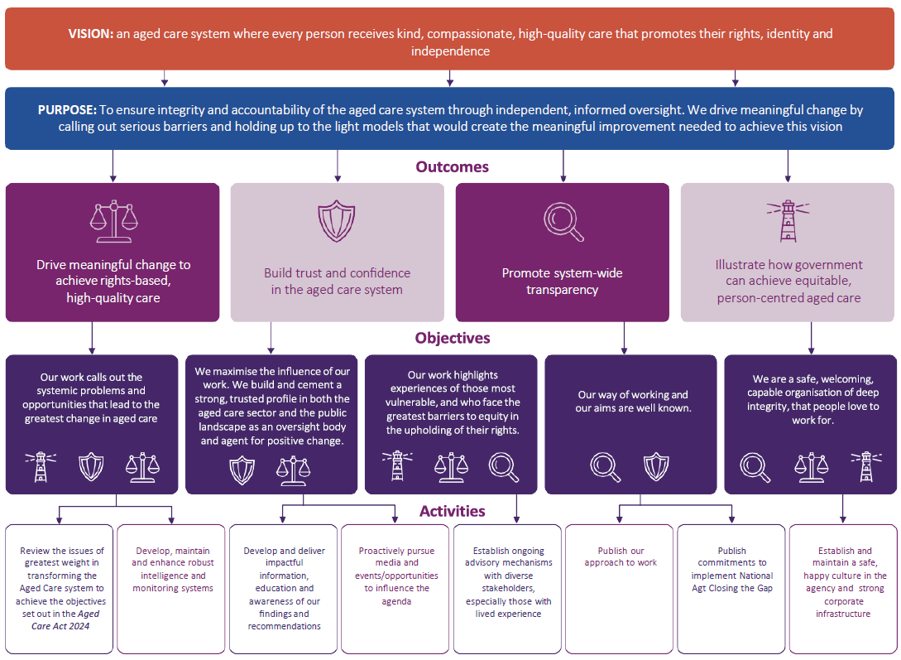
Figure 1: Office of the Inspector-General of Aged Care Strategic Framework

Outcomes
Our Strategic Framework identifies four outcomes that support our purpose. These outcomes describe the broader impacts we aim to achieve through our oversight and engagement activities:
- Drive meaningful change to achieve rights-based, high-quality care.
- Build trust and confidence in the aged care system.
- Promote system-wide transparency.
- Illustrate how government can achieve equitable, person-centred aged care.

Objectives
Our objectives explain how we will achieve these outcomes and where we will focus our resources and efforts in the coming years.
- Our work calls out the systemic problems and opportunities that lead to the greatest change in aged care.
- We maximise the influence of our work. We build and cement a strong, trusted profile in both the aged care sector and the public landscape as an oversight body and agent for positive change.
- Our work highlights experiences of those most vulnerable and who face the greatest barriers to equity in the upholding of their rights.
- Our way of working and our aims are well known.
- We are a safe, welcoming, capable organisations of deep integrity that people love to work for.
Together, the objectives and activities in our Strategic Framework shape the priorities in our Annual Work Plan. They guide how we allocate resources and focus our efforts to deliver meaningful, lasting change across the aged care system.

Annual Work Plan
Each year the Inspector-General develops and publishes an Annual Work Plan, as required under our legislation. While publishing the Annual Work Plan fulfils a legislated obligation, we also view it as a vital demonstration to the community that we have listened to their priorities in overseeing the aged care system –and that we are committed to acting on them. The plan sets out the specific activities, projects and priorities we will focus on over the coming year. It translates the long-term goals of our Strategic Framework into clear, practical actions.
In 2025–26 our Annual Work Plan activities have been determined based on the community’s response to the critical question: what actions would be most transformative in moving us from where we are today, to an aged care system that centres rights and embodies the kindness, compassion, quality of life and dignity promised by the new Aged Care Act 2024? This is the rationale behind the plan’s theme: From Aspiration to Action: Realising Human Rights and Person-Centred Care in Aged Care.
This question was the centrepiece of the comprehensive consultations we conducted (and submissions received) for our report into the government’s implementation of the recommendations of Royal Commission into Aged Care Quality and Safety. In that report we heard from people who have lived and living experience, from providers, loved ones and the government.
The Annual Work Plan reflects our commitment to improving the aged care system by supporting high-quality, rights-based care, strengthening public trust and promoting transparency.
By aligning our work with the outcomes in our Strategic Framework, we can respond to changes in the aged care environment and ensure our efforts are targeted for maximum impact.
This Corporate Plan will underpin the delivery of these focus activities.

Sharing what we learn
Our Annual Work Plan guides our priorities and shapes the insights we share from our work. These insights are shared through clear and accessible information that helps people understand how the aged care system is performing and where improvements are needed. By identifying serious barriers and showing how the government’s ambitions for aged care might be achieved, we contribute to informed public discussion and help improve outcomes for everyone who relies on or works in the aged care system.
We aim to empower people by sharing insights that build awareness of what quality, compassionate and rights-based aged care looks like in practice.
We are committed to sharing our work in ways that are practical, meaningful and easy to access. We do this through reports, fact sheets, webinars and other resources that support the sector and the entire community to understand the importance of our findings – and what they mean the government may need to change.
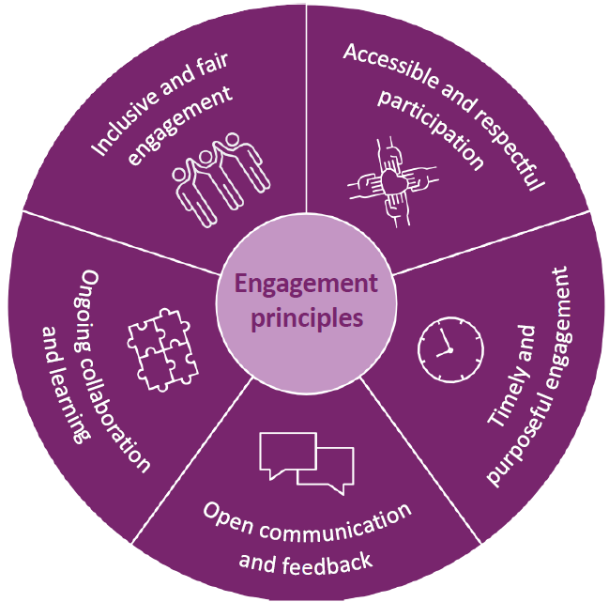

Our commitment to engagement
Building on our commitment to transparency, we actively engage with the people and organisations involved in our work to inform and improve what we do. We listen to and learn from older people, their families, carers, aged care workers, providers and community representatives.
We value the voices of people from all backgrounds, abilities, genders and sexual orientations, and are committed to making sure our work reflects and responds to the diversity of Australia’s population. This includes how we engage, communicate, design programs and share information.
We are working to improve the accessibility of our materials by using plain language and offering information in a range of formats, such as Easy Read and translations, so that more people can participate in and benefit from our work.
Our engagement is guided by clear principles that support respectful, inclusive and meaningful participation.
These Engagement Principles help ensure everyone feels heard and valued:
- Inclusive and fair engagement: we listen to all voices, with a focus on older people and those who face barriers to participation.
- Accessible and respectful participation: we use plain language, offer information indifferent formats and adapt our approach to meet individual and cultural needs – in ways that are safe, inclusive and trauma informed.
- Timely and purposeful engagement: we engage early, give people time to prepare and clearly explain the purpose of each activity.
- Open communication and feedback: we are open and transparent about how input will be used and share updates on decisions and outcomes.
- Ongoing collaboration and learning: we build long-term relationships and use what we learn to continually improve.
For more detail, see our Engagement Principles and Practice.

Partnering with Aboriginal and Torres Strait Islander peoples
Improving aged care in Australia cannot happen without learning from and working alongside Aboriginal and Torres Strait Islander peoples.
For generations, they have modelled how to care for older people in ways that are grounded in connection, respect and intergenerational responsibility.
We are committed to the National Agreement on Closing the Gap and to the principles of genuine engagement, deep listening, shared power and leadership. This is not a symbolic commitment but central to how we shape, deliver and report on our work – and we expect to be held to account for it.
We are proud to work in partnership with Aboriginal and Torres Strait Islander peoples, including through our close collaboration with the First Nations Aged Care Commissioner, to ensure cultural knowledge, lived experience and leadership inform every stage of our oversight.
Our Statement of Commitment aligns closely with our strategic framework and reinforces our vision for a kind, compassionate and rights- based aged care system. It also reflects our belief that the most transformational change comes from genuine listening, shared decision making and openness to new ways of working.
Read more in our Statement of Commitment to the National Agreement on Closing the Gap.
With our Strategic Framework, Engagement Principles and commitment to working in partnership with Aboriginal and Torres Strait Islander peoples in place, we now turn to the key activities that bring our purpose to life and support lasting improvements across the aged care system.

Key activities

How we deliver on our purpose
Our work is guided by the functions and powers of the Inspector-General of Aged Care, as set out in the IGAC Act. We focus on identifying both the barriers to achieving our vision for aged care, as well as the opportunities the government could adopt to deliver meaningful and continuous improvement.
Our approach is grounded in inclusive and respectful engagement, informed by a wide range of perspectives and with an emphasis on hearing from people with lived experience of aged care. We draw on robust data and evidence to target our efforts where they are most needed and where they can have the greatest impact.
We analyse this evidence to understand system performance, identify challenges and highlight models of care that are working well. Through ongoing monitoring, in-depth reviews and clear reporting we hold the government’s administration of the aged care system to account, and offer credible advice on how change can be achieved. By publishing our findings and making them widely accessible we support informed public discussion and help build public trust in the system.

Operating context

Environment
Australia’s aged care landscape continues to evolve as an unprecedented proportion of the population grows older and the future is likely to see less people of working age contributing to the revenue that would fund aged care. Simultaneously, the right to live independently at home for as long as possible is better recognised and the increasing demand for community-based and flexible care options highlights the need for a system that is adaptable, fair and responsive to diverse needs.
The Australian Government is leading a major program of reform across the aged care system to address longstanding challenges and improve outcomes for older people and their communities. A key part of this reform is the introduction of the new Aged Care Act 2024 which aims to create a system that looks to the future, protects human rights, helps people to live active and meaningful lives, and supports kind, respectful and high-quality care. The Act continues with a rationed model, rather than adopting the entitlement-based approach recommended by the Royal Commission. While this reflects broader funding settings, the legislation places strong emphasis on choice, dignity and fair access.
As part of our oversight responsibilities, we will continue to assess how effectively these reforms are achieving the cultural and structural transformation envisioned by the Royal Commission. We are also mindful of the potential for unintended impacts, particularly where new funding models like the introduction of co-payments for home care may place additional pressure on those with limited financial means. Featured disproportionately in this group are individuals who already encounter barriers to accessing aged care, such as Aboriginal and Torres Strait Islander peoples, culturally and linguistically diverse individuals, people with disability or cognitive decline, those living in rural and remote communities, and people experiencing economic or social disadvantages.
In addition to aged care reforms, broader pressures such as workforce shortages, cost- of-living challenges and the ongoing impacts of natural disasters continue to affect the safe and consistent delivery of aged care services, especially in rural, regional and remote communities.
The complexity and pace of reform, combined with these external pressures, shape the operating environment in which we carry out our independent oversight. Our unique role in holding government bodies to account for the administration, regulation, funding and delivery of aged care services is integral to the fair and transparent implementation of these reforms. Our legislative independence and specialised approach are central to fulfilling this responsibility.

Capability
As a small agency with a broad mandate, we focus our resources on priorities that best support our purpose and objectives. We continue to build workforce capability by developing our people’s skills, helping them achieve both organisational goals and their own professional aspirations.
We invest in the systems, technology and data infrastructure that support the efficient and high-quality delivery of our work. Our structure and governance arrangements ensure clear accountability and effective decision making across the agency.
As we grow, we prioritise knowledge sharing and skill development across all of our work, with a recent emphasis on our procurement, contract management and human resource policies. Wherever possible, we ensure essential work is carried out by APS employees. We foster a diverse, inclusive and resilient workforce with a strong ethical foundation, and we support flexible work practices that encourage innovation, collaboration and adaptability.

Workforce
We are funded for 21 full-time equivalent (FTE) roles, in addition to the Inspector-General.
Our workforce is employed under the Public Service Act 1999, which provides the legislative framework for Australian Public Service (APS) employment. This framework supports a flexible and principles-based approach to workforce management. Terms and conditions of employment are set out in our Enterprise Agreement 2024–27.
As an APS agency we maintain a small, agile and capable workforce. Our staffing profile includes a mix of ongoing and non-ongoing APS employees. We do not outsource our core work. Instead, we deploy our resources flexibly to respond to changing business needs.
We continue to focus on attracting, developing and retaining high-calibre staff to support our purpose and strategic objectives. We will strengthen our workforce capability through ongoing planning, skills development and targeted recruitment.
In all our activities we uphold the APS Values and Code of Conduct, as set out in the Public Service Act 1999. We are committed to maintaining ethical, inclusive and accountable workforce practices, ensuring they are fair and free from bias.

Workforce culture
We are committed to fostering a safe, positive and supportive workplace culture, built on deep integrity and supported by strong corporate systems. Our way of working is grounded in transparency, professionalism and respect. We aim to ensure our purpose, values and approach are clearly communicated and understood across the agency and by our stakeholders.
We value the contribution that a diverse workforce brings and we strive to create an inclusive, welcoming environment where people feel valued and inspired to do their best work. We embrace the variety of experiences, skills and perspectives that our people bring to the workplace. Our goal is to be recognised for the positive difference our workforce makes for those we serve.
In line with the Australian Government’s commitment to reconciliation, we have published our commitment to implementing priority reforms under the National Agreement on Closing the Gap and we will continue to strengthen our internal capability to support these important priorities.
We are also committed to developing comprehensive diversity and inclusion policies that build on and reinforce these commitments over time. This means creating a workplace where people of all backgrounds, identities and experiences feel respected, supported and able to thrive. We want to ensure that First Nations peoples, people from culturally and linguistically diverse backgrounds, people with disability and LGBTIQ+ people are interested in working with us and are genuinely included and valued.

Organisational structure
Organisational structure on 1 August 2025
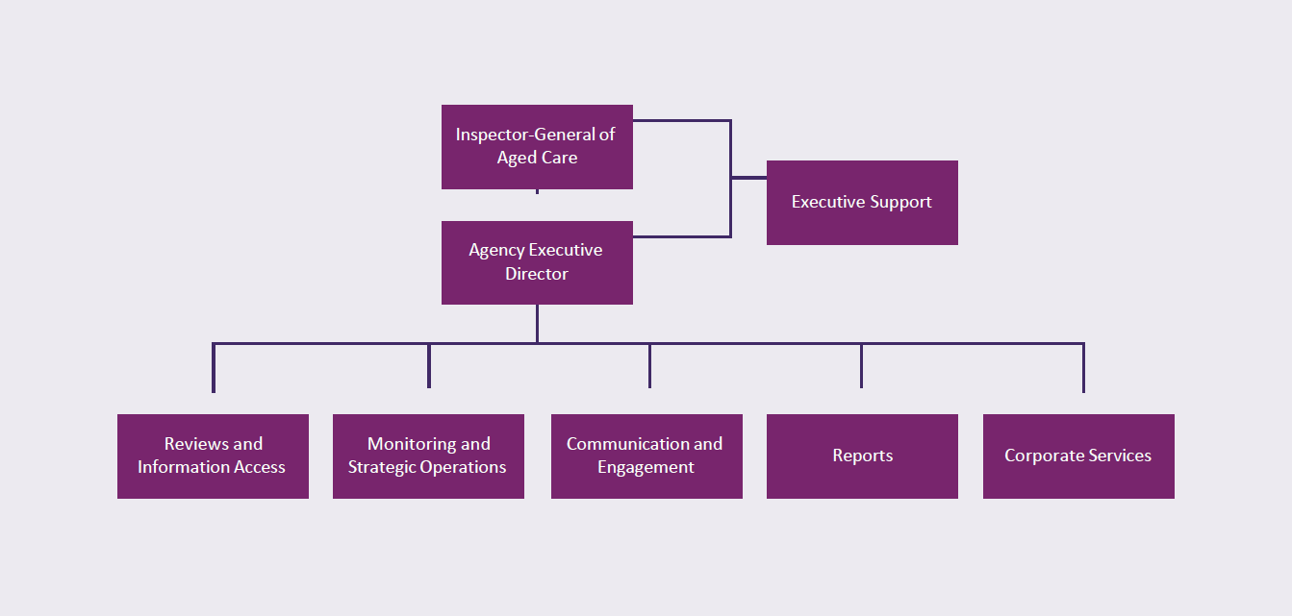

Technology
We continue to assess and enhance the technology, data and analytical tools that support the delivery of our functions. Our systems must remain robust, reliable, secure and fit for purpose to ensure we can meet our responsibilities effectively and efficiently.
Our people and technology work together to deliver our purpose. This capability is guided by principles that ensure integrity, independence and accountability in everything we do.

Our principles
Our guiding principles shape how we work, how we engage with others, and how we fulfil our purpose: promoting an accountable, fair and high-quality aged care system through independent oversight. We are committed to ensuring our work is inclusive and responsive to the diverse needs of everyone we serve. This includes First Nations peoples, people from culturally and linguistically diverse backgrounds, people with disability, LGBTIQ+ communities, and all individuals who bring different perspectives, identities and life experiences. This commitment guides our approach to engagement, communication and decision-making across all areas of our work.
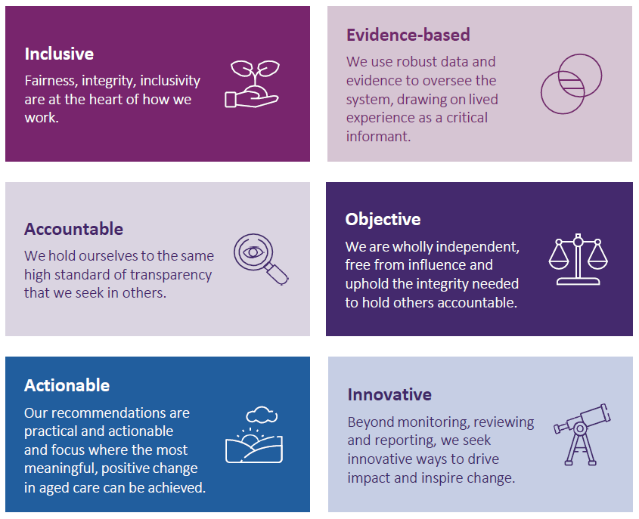
Our principles form the foundation of our governance framework and support effective risk oversight and assurance activities.

Risk oversight

Oversight and assurance
A strong corporate governance framework is essential to managing our strategic and operational activities. It supports us in achieving our purpose and delivering on our objectives.
Our independent Audit and Risk Committee meets 4 times a year and is a key part of our governance arrangements. The committee provides independent oversight and review of our risk management, financial management, performance reporting and assurance systems.

Risk management and key risks
Effective risk management is central to supporting our agency’s strategic direction. We regularly report against our risk management framework, including policies and a risk register, to identify, respond to and actively manage our key risks.
Our approach aligns with the Commonwealth Risk Management Policy and reflects our risk appetite to maintain high standards of accountability and integrity.
Risk management is everyone’s responsibility. We encourage early and open discussions about risks, recognising their importance in identifying and managing new or emerging issues.

Cooperation
We operate independently and impartially, while maintaining respectful and professional working relationships with the agencies within our oversight scope, including:
Department of Health, Disability and Ageing
Aged Care Quality and Safety Commission
Independent Health and Aged Care Pricing Authority.
While the Inspector-General has strong statutory powers to gather information, we always seek constructive and collaborative approaches to seeking information first. We aim to be practical in accessing information in a manner that is timely and secure.
These cooperative efforts, supported by open lines of communication where appropriate, assist us in monitoring, analysing, reviewing and reporting on the administration of the aged care system while preserving our independence.
Our cooperative approach is guided by respect, transparency and the understanding that constructive approaches are best, while still maintaining our independence.
Alongside our strong internal oversight, we recognise the importance of working cooperatively with others to achieve our objectives.

Performance

Our outcome objective
The outcome objective against which our overall performance will be assessed is:
Provide independent oversight of the aged care system to drive accountability and positive change through reviews, recommendations and reporting to Parliament.

How we will measure our performance
The table below outlines the performance measures we will use to assess our key activities.
Table 1. Performance measures for 2025–26 to 2028–29
 | Key performance measure | Target 2025–26 | Target 2026–29
1 | Maximise the influence of our work. Number of citations and/or references to the work of the office in parliamentary debates/forums, social media traffic and media/sector publications. | 200 media mentions per year  1,000 Social Media followers  30 speeches and/or representation on external panel by the IGAC or members of the executive | Reasonable increased growth year on year
2 | Proportion of publications, products and activities that draw on people’s lived experience | Engage with active lived experience advisory groups quarterly  80% of Lived experience participants report positive engagement and reflection of their views in the annual stakeholder engagement review  80% of surveyed stakeholders from Aboriginal and Torres Strait Islander communities and CALD communities report positive engagement and reflection of their views in the annual stakeholder engagement review | As per 2025–26
3 | Effective stakeholder engagement with relevant committees, advisory bodies, agencies, organisations and the public | Biennial increase in stakeholder awareness scores from targeted surveys across aged care providers, advocacy groups, and the public.  70% of respondents to surveys report hearing heard and valued | Reasonable increases biennially
4 | Number of publications, products and activities generated by the Office that identify systemic issues and/or opportunities for sector-wide improvements | Tally of the outputs show 80% identify systemic issues and/or discuss opportunities for sector-wide improvement | As per 2025–26



www.igac.gov.au

